

YOUR DIGITAL LAB
DECODE LABS REMOTE INTERNSHIP 2026
- STUDENT NAME: ALEEM SHOUKAT
- INETRNSHIP DOMAIN: DATA SCIENCE
- DATE: 23/JUNE/2026
- TASK # 03(WEEK#03)
CUSTOMER SEGMENTATION USING PCA AND K-MEANS CLUSTERING

Abstract
Customer segmentation is an important business analytics technique used to identify groups of customers with similar behavior. This project applies Principal Component Analysis (PCA) and K-Means Clustering to segment mall customers into meaningful groups based on demographic and spending characteristics.
The objective was to discover hidden customer patterns without using labeled data. PCA was applied for dimensionality reduction, while K-Means clustering was used to identify customer groups. The Elbow Method and Silhouette Score were used to determine the optimal number of clusters. Finally, customer personas were created to support data-driven business decisions.

1. Introduction
Businesses collect large amounts of customer data, but raw data alone does not provide actionable insights. Customer segmentation helps organizations understand different customer groups and design targeted marketing strategies.
In this project, an unsupervised machine learning approach was used to divide customers into distinct segments based on their purchasing behavior and demographic characteristics.

2. Dataset Overview
The Mall Customers dataset was used for this analysis.
Dataset Information
Attribute | Value
Total Records | 200
Features | 5
Numerical Features | Age, Annual Income, Spending Score
Categorical Feature | Gender
Missing Values | 0
Duplicate Records | 0
Features Used
- Gender
- Age
- Annual Income
- Spending Score

3. Data Preprocessing
The following preprocessing steps were performed:
- Loaded the dataset using Pandas.
- Checked dataset structure and data types.
- Verified missing values.
- Checked duplicate records.
- Encoded Gender using Label Encoding.
- Removed CustomerID column.
- Applied StandardScaler for feature normalization.
Why Standardization?
Since Age, Income, and Spending Score are measured on different scales, StandardScaler was used to ensure that all features contribute equally during clustering.

4. Dimensionality Reduction using PCA
Principal Component Analysis (PCA) was applied to reduce the dataset from four dimensions to two dimensions.
Results
Metric | Value
Original Features | 4
Principal Components | 2
Variance Retained | ~60%
PCA simplified the dataset while preserving most of the important information.
Figure 1: PCA Customer Distribution
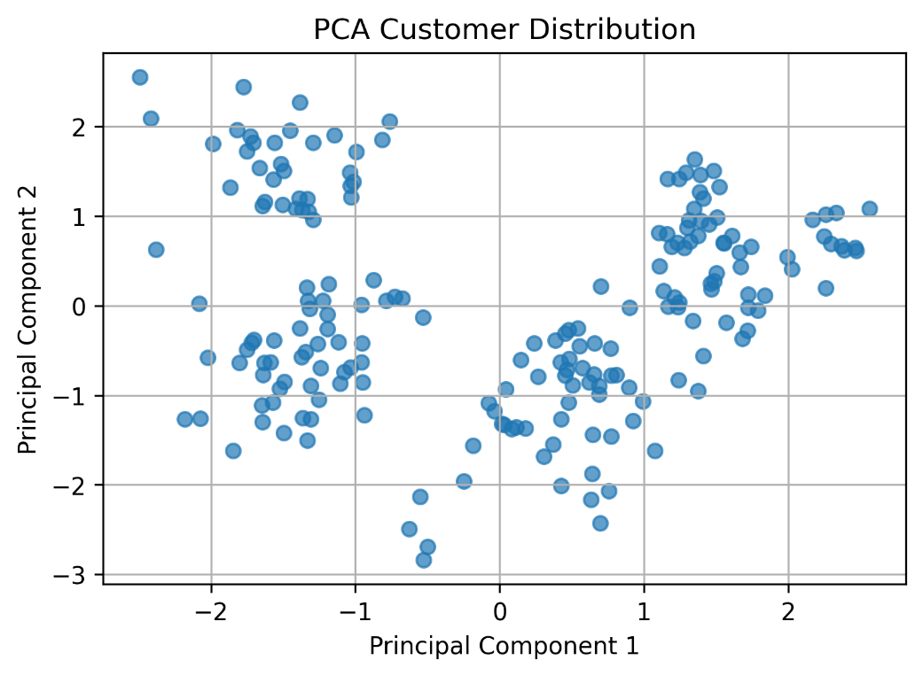

5. Optimal Cluster Selection
To determine the best number of clusters, two evaluation techniques were used.
5.1 Elbow Method
The Elbow Method measures Within Cluster Sum of Squares (WCSS). The optimal cluster count is identified at the point where additional clusters provide diminishing improvements.
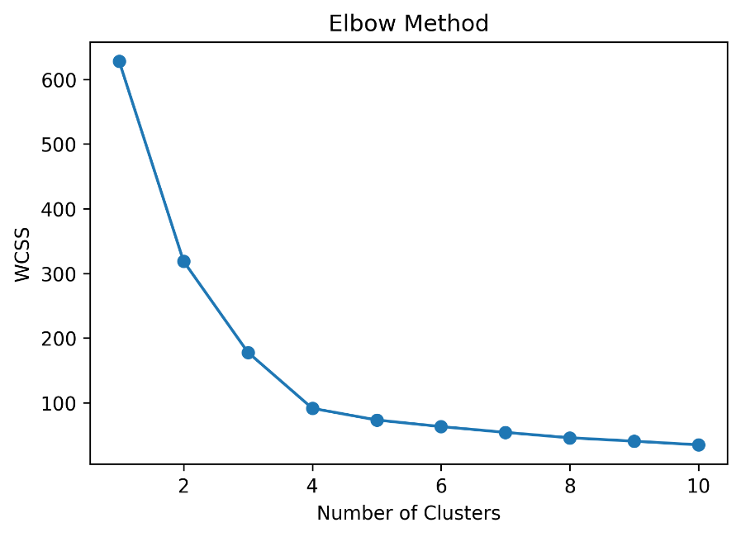
Figure 2: Elbow Method

Observation
The elbow point appeared at K = 4.
5.2 Silhouette Score
The Silhouette Score evaluates how well each data point fits within its assigned cluster compared to other clusters.
Results
Highest Silhouette Score:
K = 4 → 0.4156
Observation
The Silhouette Score confirmed that four clusters provide the best balance between cohesion and separation.

6. Customer Segmentation using K-Means
The K-Means algorithm was applied using K = 4.
Cluster Distribution
Cluster | Customers
0 | 34
1 | 51
2 | 54
3 | 61
Figure 3: Customer Segments using K-Means
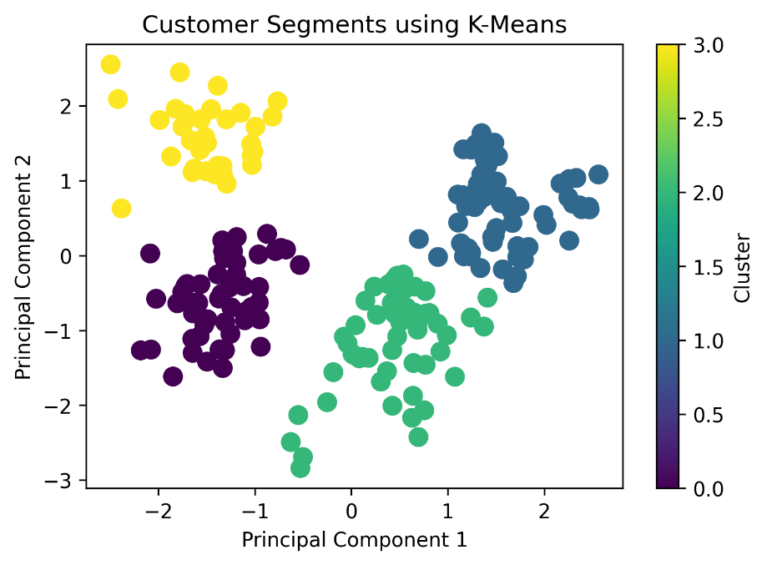

Observation
The algorithm successfully separated customers into four visually distinct groups.

7. Customer Personas
Cluster centroids were analyzed to create meaningful customer personas.
Cluster | Persona Name | Average Age | Average Income | Average Spending
0 | High-Value Customers | 29.91 | 81.50 | 73.88
1 | Conservative Customers | 47.65 | 74.63 | 30.86
2 | Budget-Conscious Customers | 49.22 | 46.22 | 34.00
3 | Young Spenders | 27.30 | 49.82 | 67.51
Business Recommendations
High-Value Customers
- Premium products
- Loyalty rewards
- Exclusive offers
Conservative Customers
- Retention campaigns
- Long-term membership programs
Budget-Conscious Customers
- Discounts and promotional offers
- Affordable product bundles
Young Spenders
- Social media marketing
- Trend-based promotions

8. Interactive Dashboard
A professional Streamlit dashboard was developed to present project findings interactively.
Dashboard Features
- Executive Summary
- Dataset Overview
- Customer Demographics
- Correlation Analysis
- PCA Visualization
- Cluster Analysis
- Customer Personas
- Business Insights
Figure 4: Streamlit Dashboard
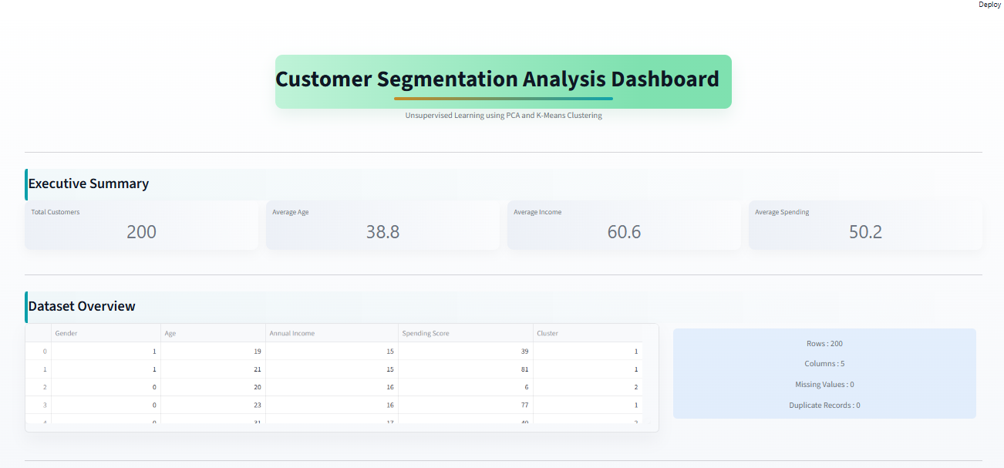
9. Key Learnings
Through this project, the following concepts were learned and implemented:
- Unsupervised Learning
- Customer Segmentation
- Label Encoding
- StandardScaler
- Principal Component Analysis (PCA)
- K-Means Clustering
- Elbow Method
- Silhouette Score
- Cluster Interpretation
- Business Persona Creation
- Streamlit Dashboard Development

10. Conclusion
This project successfully applied PCA and K-Means Clustering to identify meaningful customer segments from unlabeled retail data.
The Elbow Method and Silhouette Score both indicated that four clusters provide the most effective segmentation structure. These customer segments were translated into actionable business personas that can help organizations improve marketing strategies, customer engagement, and revenue generation.
The project demonstrates how unsupervised machine learning can transform raw customer data into valuable business intelligence.
--------------------------------------------

